የመድኃኒትጎጂባህርያትክትትልስርአትለምንያስፈልጋል?
እንደሚታወቀውመድኃኒቶችተዘጋጅተውለህዝብጥቅምከመዋላቸውበፊትየቅድመፈቃድምርምሮችይካሄዱባቸዋልነገርግንእነዚህምርምሮችመድኃኒቶቹበተጠቃሚዎችላይሊያስከትሉስለሚችሉትጎጂባህርያትወይምሳይድኢፌክትበበቂመጠንአያስገነዝቡም።ስለዚህማንኛውንምመድኃኒትወይምየህክምናአገልግሎትመስጫግብአትወይምየላቦራቶሪመመርመሪያለህዝብጥቅምላይበሚውልበትወቅትበተጠቃሚውላይሊያስከትላቸውየሚችሉትንአላስፈላጊጎጂባህርያትመከታተልናእንደአስፈላጊነቱእርምጃእየወሰዱማስተካከልናጉዳቶችንመከላከልያስፈልጋል።
በተለይምተጠቃሚዎችየጤናባለሙያሳያዝላቸውናሳያማክሩበግላቸውገዝተውወይምከሰውወስደውየሚጠቀሙባቸውመድኃኒቶችከፍተኛአደጋሊኖራቸውስለሚችልጉዳቱበድጋሚእንዳይከሰትባቸውወይምደግሞበተመሳሳይሌላተጠቃሚእንዳይኖርመከታተል፣መረጃማዳበርናመከላከልይገባል።
የመድኃኒትጎጂባህርያትሪፖርትንለየትኛውየመንግስትአካልነውሪፖርትየምናደርገው?
ይህንንክትትልበሳይንሳዊመንገድለመፈጸምናህብረተሰቡንበመድኃኒትወይምየህክምናአገልግሎትመስጫግብአትወይምየላቦራቶሪመመርመሪያአጠቃቀምወቅትከሚከሰትጎጂባህርይወይምየጥራትጉድለትለመከላከልየኢትዮጵያየምግብናመድኃኒትቁጥጥርባለስልጣንበአዋጅበተሰጠውመብትበመጠቀምጉዳቱበሚደርስበትወቅትሪፖርቶችንከተጠቃሚዎችወይምከጤናባለሙያዎችይሰበስባልየማጣራትናየምርመራስራምይሰራል።የምርመራውንውጤትምተጠቅሞምበተለያዩመድኃኒቶች፣የህክምናአገልግሎትመስጫግብአቶችናየላቦራቶሪመመርመሪያመሳሪያዎችላይየማስተካከያእርምጃዎችንይወስዳል።
የትኞቹንየመድኃኒትጎጂባህርያትነውሪፖርትየምናደርገው?
በመሆኑምየማንኛውምመድኃኒት፣የህክምናአገልግሎትመስጫግብአቶችናየላቦራቶሪመመርመሪያመሳሪያዎችጎጂባህርያት፣እንዲሁምየመድኃኒትየጥራትጉድለትበሚያጋጥምበትወቅትየሚከተሉትንአራትሪፖርትየማድረጊያመንገዶችበመጠቀምለባለስልጣኑማሳወቅይገባል።
ማንኛውምየመድኃኒትጎጂባህርያትበሚያጋጥምበትወቅትለኢትዮጵያየምግብናመድኃኒትባለስልጣንሪፖርትየማድረጊያመንገዶቹየሚከተሉትናቸው።

- ፖስታመሰልቢጫፎርም
ይህሪፖርትማድረጊያመንገድባለስልጣኑከረጅምጊዜጀምሮአዘጋጅቶበጤናተቋማት፣በጤናቢሮዎችናበቅርንጫፍመስሪያቤቶችያስቀመጠውቢጫፎርምነው።በዚህፎርምውስጥአስፈላጊየሆኑናበአግባቡተሞልተውመላክያለባቸውመረጃዎችየሚከተሉትሲሆኑ
- የመጀመሪያውመረጃ፡መድኃኒትወይምየህክምናአገልግሎትመስጫግብአቶችወይምየላቦራቶሪመመርመሪያመሳሪያዎችተጠቅሞጉዳትየደረሰበትሰውመገለጫዎችማለትምእድሜ፣ጾታ፣ክብደት፣ቁመትሲሆኑ (Patient information)
- ሁለተኛውመረጃ፡ጉዳቱንያደረሰውመድኃኒትወይምየህክምናአገልግሎትመስጫግብአትወይምየላቦራቶሪመመርመሪያመሳሪያዎችመገለጫዎችናቸውአነዚህም፤( ስም፣መለያቁጥር፣የንግድስም፣አምራችወይምአከፋፋይ፣የተመረተበትቀን፣የአገልግሎትዘመኑየሚያበቃበትቀን፣መድኃኒቱመወሰድየተጀመረበትቀንወይምጥቅምላይየዋለበትቀን፣ጎጂባህርይመታየትየጀመረበትቀን፣መድኃኒቱተቋርጦከሆነየተቋረጠበትቀን፣መድኃኒቱየታዘዘበትወይምየተወሰደበትምክንያትናቸው(Drug information)
- ሶስተኛውመረጃ፡መድኃኒቱወይምየህክምናአገልግሎትመስጫግብአቱወይምየላቦራቶሪመመርመሪያመሳሪያውያደረሰውጉዳትወይምሳይድኢፌክትምልክቶችዝርዝርናቸው(Adverse drug event description)
- አራተኛውመረጃ፡መድኃኒቱወይምየህክምናአገልግሎትመስጫግብአቱወይምየላቦራቶሪመመርመሪያመሳሪያውጥቅምላይከመዋልተቋርጦከሆነ፣ሲቋረጥየጉዳቱምልክትጠፍቶከሆነ፣በጉዳቱምክንያትሆስፒታልመግባትአስፈልጎከሆነ፣መድኃኒቱወይምየህክምናአገልግሎትመስጫግብአቱከጉዳቱበኋላበድጋሚጥቅምላይውሎከሆነየሚገልጹናቸው(Reaction information)
- አምስተኛውመረጃ፡ጉዳቱንለማከምየተወሰደውየህክምናአይነትይሆናል(Treatment information)
- ስድስተኛውመረጃ፡የጉዳቱውጤትማለትምከጉዳቱበኋላተጠቃሚውተሻለውወይ፣ሞተወይ፣አሁንምበጉዳትላይነውወይየሚሉትይሆናሉ(Outcome)
- ሰባተኛውመረጃ፡በጉዳቱምክንያትየደረሰቀሪጉዳትማለትምጠባሳየአካልመጉደልወይምሌላይሆናል(sequelae)
- ስምንተኛውመረጃ፡ስለተጠቃሚውወቅታዊየጤናሁኔታተጨማሪመረጃማለትምየጉበት፣ኩላሊትሁኔታወይምየሌላአካልክፍልየጤናሁኔታሴትከሆነችደግሞእርግዝናይሆናል(Relevant medical information)
- ዘጠነኛውመረጃይህንንጎጂባህርይወይምጉዳትሪፖርትያደረገውሰውአድራሻማለትምስም፣ስልክ፣ሙያ፣ኢሜይልአድራሻ፣የጤናተቋሙስምክልልናቸው(Reporter information)

በተጨማሪምየመድኃኒትወይምየህክምናአገልግሎትመስጫግብአትወይምየላቦራቶሪመመርመሪያየጥራትጉድለትሲያጋጥምየቢጫፎርሙንከጀርባውበኩልያለውንቦታበመጠቀምየመድኃኒቱንወይምየህክምናአገልግሎትመስጫግብአቱንወይምየላቦራቶሪመመርመሪያውንስምናሌሎችመገለጫዎችን፤ያጋጠመውንየጥራትጉድለትማለትምለምሳሌለእንክብሎች (የከለርመቀየር፣የተለየሽታ፣መሰባበር፣መሰነጣጠቅ፣ከቁጥርመጉደል)፤ለሽሮፕናሌሎችፈሳሽመድኃኒቶች ( ብልቃጡላይመድኃኒቱመዝቀጥናቢወዘወዝምአለመላቀቅ)፣ለመርፌመድኃኒቶችናግሉኮሶች ( በውስጡየሚታይወይምየሚስረከረክባእድነገር፣የከለርመቀየር)፤ለላቦራቶሪመመርመሪያዎች ( ትክክለኛያልሆነአጠራጣሪውጤት false positive false negative) እንዲሁምበማንኛውምመድኃኒትወይምየህክምናአገልግሎትመስጫግብአትወይምየላቦራቶሪመመርመሪያዎችውጫዊሽፋንላይሊኖሩየሚገቡመረጃዎችበአግባቡአለመኖርእነዚህንናሌሎችንምአጠራጣሪየጥራትሁኔታዎችንበመመሙላትለባለስልጣኑሪፖርትማድረግይቻላል።

በመጨረሻምበቢጫፎርሙላይመረጃዎቹበሙሉከተሞሉበኋላምልክቱንበመከተልበማጠፍናበማጣበቂያውበማጣበቅየፖስታቅርጽሲኖረውየላኪንአድራሻበመጻፍበፖስታቤትመላክይገባልወይምበአካልቦሌከሸዋሱፐርማርኬትከፍብሎበሚገኘውየባለስልጣንመስሪያቤትበአካልበመምጣትመስጠትይቻላል።

ፖስታመሰልቢጫፎርምይህንይመስላል (The yellow, prepaid report form available at the facility Annex 1)
Annex I : The yellow, prepaid report form available at the facility Annex 1)
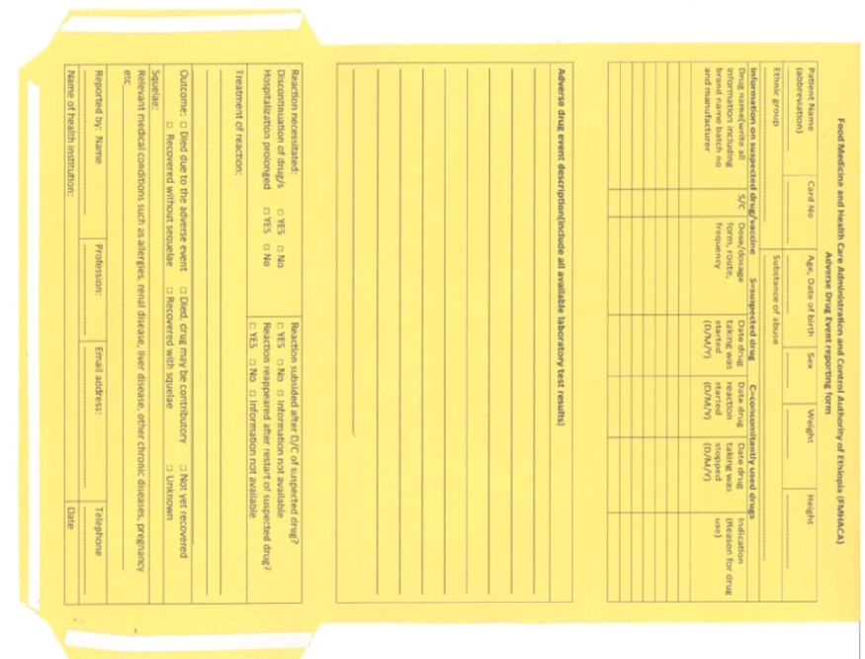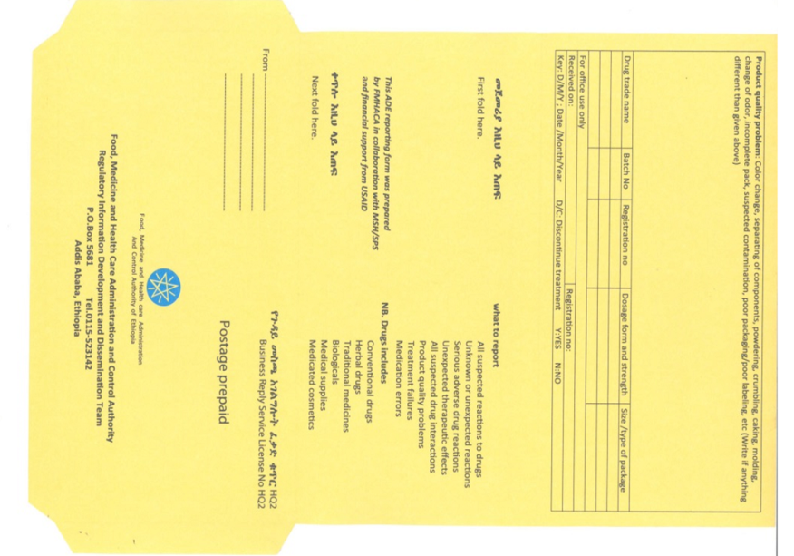

- ሁለተኛውሪፖርትማድረጊያመንገድየባለስልጣኑነጻየስልክመስመርሲሆንቁጥሩም 8482 (toll free line) ሲሆንበማንኛውምየስራሰአትበመደወልስለተከሰተውየመድኃኒትወይምየህክምናአገልግሎትመስጫግብአትወይምየላቦራቶሪመመርመሪያዎችጎጂባህርይወይምየጥራትጉድለትበአንደኛውሪፖርትማድረጊያመንገድላይየተጠቀሱትንመረጃዎችበመያዝሪፖርትማድረግይቻላል.

- ሶስተኛውመንገድበባለስልጣኑዌብሳይትውስጥwww.fmhaca.gov.et-serivces-e-Reportingበሚለውበመግባትሪፖርትአድራጊውግለሰብስሙንናየኢሜይልአድራሻውንበመሙላትከገባበኋላከላይበአንደኛውመንገድየተጠቀሱትንየመድኃኒትወይምየህክምናአገልግሎትመስጫግብአትወይምየላቦራቶሪመመርመሪያስለተከሰተውጎጂባህርይወይምየጥራትጉድለትአስፈላጊመረጃዎችበመያዝእያንዳንዱንገጽእየሞሉወደሚቀጥለውገጽበማለፍመጨረስናመላክይቻላል።ለተጨማሪመረጃዝርዝርመመሪያውንይመልከቱ (See instructions on Annex II).

Annex II: Instruction for web based electronic reporting system
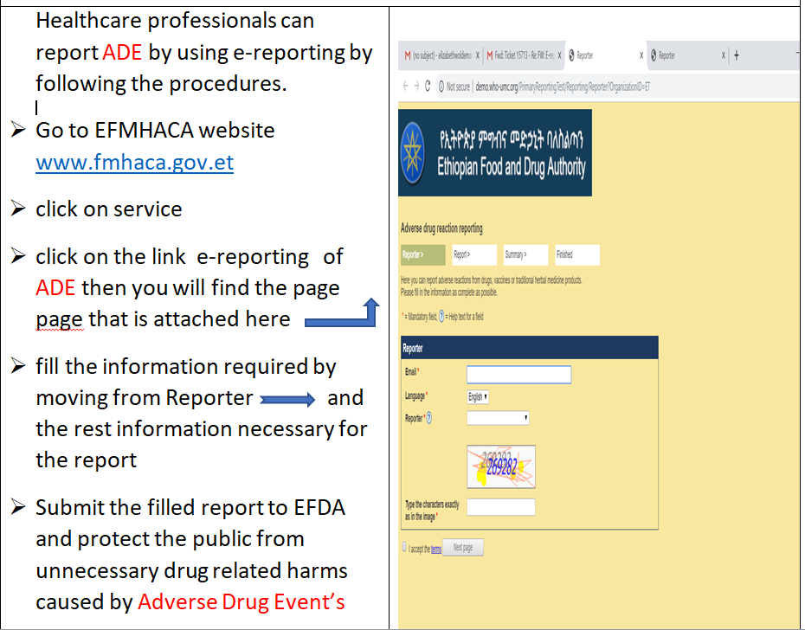

- አራተኛውመንገድየሞባይልአፕልኬሽኖችንበመጠቀምሪፖርትማድረጊያመንገድሲሆን
በመጀመሪያለአንድሮይድስልክተጠቃሚዎችጎግልስቶርንበመጠቀምለአይፎንተጠቃሚዎችደግሞአፕእስቶርንበመጠቀምmedsafetyየተባለውንአፕልኬሽንማውረድ( ዳውንሎድማድረግ )ያስፈልጋልበመቀጠልምአፕልኬሽኑን install ማድረግከዚያምአፕልኬሽኑንመክፈትናኢትዮጵያየሚለውንምልክትመንካትበመቀጠልምለተጠቃሚውብቻየሚያገለግል user name እና password በመስጠትየግልአካውንትመክፈትያስፈልጋል።
በማስከተልምልክከላይእንደተጠቀሱትሪፖርትማድረጊያመንገዶችሁሉአስፈላጊውንየመድኃኒትወይምየህክምናአገልግሎትመስጫግብአትወይምየላቦራቶሪመመርመሪያዎችጎጂባህርይወይምየጥራትጉድለትመረጃዎችበመያዝአፕሊኬሽኑንበመከተልበየገጹእየሞሉወደሚቀጥለውገጽእያለፉመጨረስናለባለስጣኑመላክይቻላል።ለተጨማሪመረጃዝርዝርመመሪያውንይመልከቱ ( See instructions on Annex III).

Annex III, Instructions for mobile based application reporting system

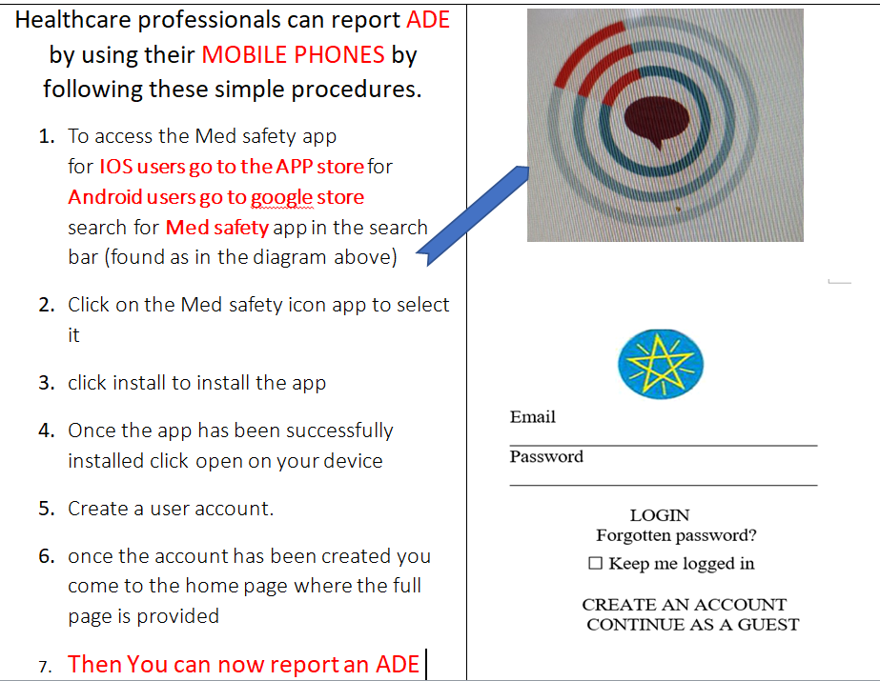

ሪፖርትከተደረገበኋላምንይደረጋል?
እነዚህንየተላኩመረጃዎችንበመጠቀምባለስልጣንመስሪያቤቱአስፈላጊምርመራዎችንበማካሄድየተለያዩየማስተካከያእርምጃዎችንይወስዳል። በመሆኑምበመድኃኒትወይምየህክምናአገልግሎትመስጫግብአትወይምየላቦራቶሪመመርመሪያዎችአጠቃቀምላይጎጂባህርይወይምየጥራትጉድለትችግርበሚያጋጥምዎትወቅትከነዚህአራትመንገዶችአንዱንበመጠቀምሪፖርትበማድረግህብረተሰቡንበመድሓኒትምክንያትከሚደርስበትአላስፈላጊጉዳትይከላከሉ ።ከላይከተጠቀሱትሪፖርትማድረጊያመንገዶችበማንኛውምአይነትመንገድቢጠቀሙየሚያስፈልጉትመረጃዎችበመጀመሪያውላይበዝርዝርየተገለጹትናቸው።
ልብይበሉ!!!!!!
በተለይምአሁንባለንበትወቅትህብረተሰቡበባለሙያታዞለትከሚጠቀምባቸውመድኃኒቶችበተጨማሪያለባለሙያትእዛዝየተለያዩባህላዊምሆነዘመናዊመድኃኒቶችንእየተጠቀመበመሆኑሊደርሱየሚችሉብዙአይነትጉዳቶችስለሚኖሩእነዚህንሪፖርትበማድረግሀገራዊሀላፊነትዎንይወጡ።

Important website for additional information on Pharmacovigilance
EFDA
http://www.fmhaca.gov.et/publications-library/
WHO
1.https://www.who.int/medicines/news/glob_pharmvig_database_qa/en/
2. https://www.who.int/medicines/news/glob_pharmvig_database_media/en/
3. https://www.who.int/medicines/publications/drugalerts/en/
USFDA
4.https://www.accessdata.fda.gov/scripts/cderworld/index.cfm?action=drugsafety:main&unit=1&lesson=1&topic=15
5. https://www.fda.gov/safety/medwatch-fda-safety-information-and-adverse-event-reporting-program/medical-product-safety-information

6.https://www.fda.gov/about-fda/contact-fda/stay-informed/rss-feeds/medwatch/rss.xml

